XoRETw Development Document
July 2015

Purpose
To port the xoRET graphical software tool (http://wi.wu-wien.ac.at/home/mark/xoRET/index.html) from Professor Strembeck to a database-driven web application.

Development Environment Overview
Linux/ubuntu
Django 1.7 (web framework)
Python 2.7 (and Python Packages: Network X/graph theory, django-registration-redux/user registration app for Django)
Bootstrap (front-end framework, HTML/CSS/Javascript)
jQuery
vis.js (Network module - data visualization)
virtualenv
SQLite3
PythonAnywhere – online IDE and web hosting service

Development Environment Setup

1. Install ubuntu 12.04 LTS
2. Open a new terminal and run the following commands:
installs pip
a. sudo apt-get install python-pip3

installs virtualenvwrapper
b. sudo apt-get install virtualenvwrapper

installs vim editor
c. sudo apt-get vim

3. Edit .bashrc (e.g. vim .bashrc)
4. Add the following lines to the .bashrc
export WORKON_HOME=$HOME/.virtualenvs
export PROJECT_HOME=$HOME/Devel (Can change/optional)
source /usr/local/bin/virtualenvwrapper.sh

5. Save .bashrc and call source to execute the contents of the .bashrc file, type the following in a terminal:
a. source ~/.bashrc
6. Install Git, type the following in a terminal:
a. sudo apt-get install git

7. Create new virtualenv, type the following in a terminal:
a. mkvirtualenv xoretw

8. Get xoRETw repository from GitHub, type the following in a terminal:
git clone https://github.com/ParametricHumanProject/xoRETw.git

9. Activate xoretw virtualenv, type the following in a terminal:
a. workon xoretw

10. Install Django
a. pip install django==1.7.8
11. Install Python Package
a. install django-registration-redux==1.1

12. Change directory to xoRETw, type the following in a terminal:
a. cd xoRETw

13. Create database tables and user account, type the following in a terminal:

create database tables in SQLite3 database (db.sqlite3)
a. python manage.py migrate (create database tables)

create new super user
b. python manage.py createsuperuser

E.g.
Username: admin
Email address: admin@xoretw.com
Password:
Password (again):

start Django's development server
c. python manage.py runserver

14. Open a web browser and navigate to localhost:8000. See Screenshots below if successful.
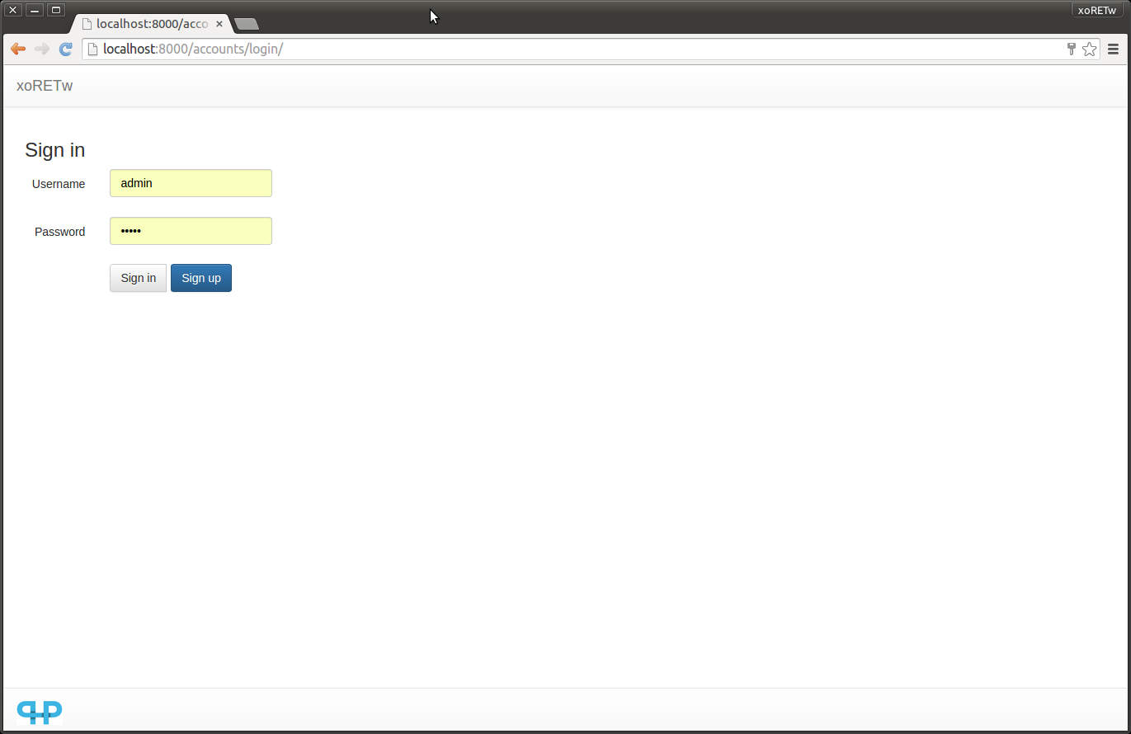
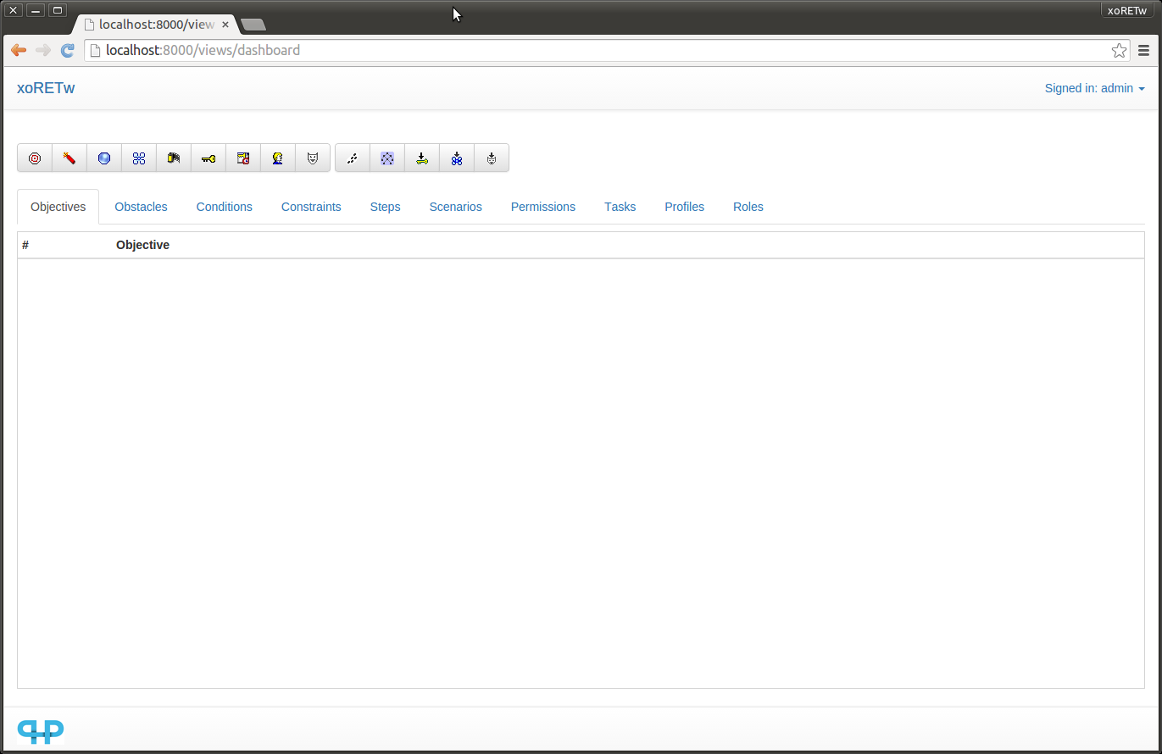

How to Run xoRET (Strembeck)

1. Open Ubuntu Software Centre
2. In the Ubuntu Software Centre search box enter 'synaptic' to search for Synaptic Package Manager
3. Install Synaptic Package Manager
4. Run Synaptic Package Manager
5. Select/install the following packages:

Search for 'tcl' and install the following packages:
tcl
tcl8.5
tcl8.5dev
libgv-tcl
xotcl-shells
xotcl
tcl-dev
xotcl-doc
xotcl-dev
tk8.5-dev
tk8.5
tk-dev
tk
tcllib

Search for 'tk' and install the following packages:
tk
tk8.5
tk-dev
tk8.5-dev

Search for graphviz and install the following packages:
libgraphviz-dev
graphviz-dev
libgv-tcl
graphviz

download and extract xoRET:
http://wi.wu-wien.ac.at/home/mark/xoRET/xoRET-ver-0.2.0.tar.gz

Sample of Synaptic Package Manager:

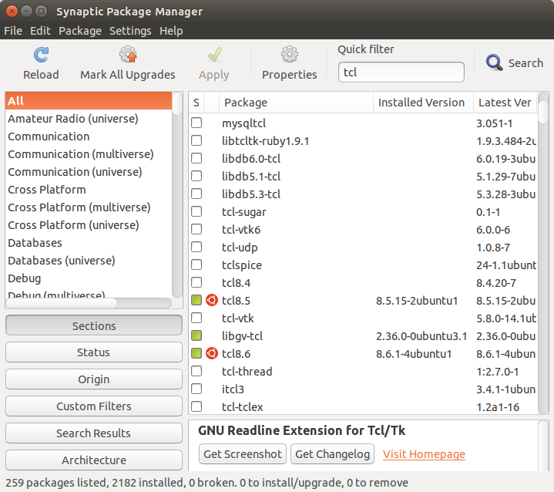

6. Change directory
a. cd xoRET-0.2

7. Change directory
a. cd examples

8. Run example file
a. wish example02.xotcl

9. Sample of running xoRET tool:

